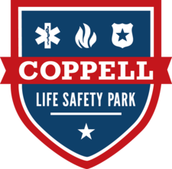
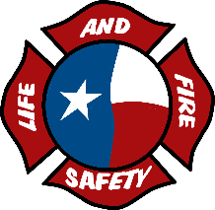
Texas LAFS 2025

Monday, May 5, 2025:
0800-0900: Registration/Check-in @ Coppell Arts Center
0845-0900: Welcome from LAFS Board & Coppell Fire Chief
0900-0930: Live Show 1 @ Coppell Arts Center
New Braunfels FD
0930-0945: Live Show 1 Q&A
0945-1000: Break
1000-1200: General Session with Neal Skoy (Clowning: The Verb & The Game) @ Coppell Arts Center
1200-1315: Lunch (On Your Own)
1315-1445: Breakout Session 1 @ Life Safety Park
Magic (Beginner) – Dusty Simmons; Haltom City Police Department
Train station
Intro to Sound Operations – Jeff Bates; Plano Fire Department
Safety House
Make-Up Beginner – Brenda Marshall & Eric Daniels; McKinney FD
Classroom A
New Program Development – Derek Paradise; Texas LAFS
Classroom B
1445-1500: Break
1500-1630: Breakout Session 2 @ Life Safety Park
Script Writing – Derek Paradise; Texas LAFS
Classroom B
Sound Operations – Jeff Bates; Plano Fire Department
Safety House
Set Construction – Bill Amos; Allen FD
Train Station
Ukulele – Josh Cawthon; Texas LAFS
Classroom A
1630-1700: End of Day Announcements
Classroom B

Tuesday, May 6, 2025:
0830-0900: Live Show 2 @ Coppell Arts Center
Haltom City FD
0900-0915: Live Show 2 Q&A
0915-0945: Live Show 3 @ Coppell Arts Center
Lake Travis FD
0945-1000: Live Show 3 Q&A
1000-1015: Break
1015-1145: Breakout Session 3 @ Life Safety Park
Magic (Advanced) – Dusty Simmons; Haltom City Police Department
Train station
“Oh Look a Prop” – Neal Skoy
Classroom B
Grant Writing – Bryce Davis; Haltom City Emergency Management
Classroom A
Sound Editing – Chris Holcomb
Safety House
1145-1315: Lunch (On Your Own)
1315-1445: Breakout Session 4 @ Life Safety Park
Puppetry – Stephanie Bouillion; Plano Fire Department
Safety House
Physical Comedy – Neal Skoy
Classroom B
Make Up (Advanced) Brenda Marshall & Eric Daniels
Classroom A
Stage Presence & Group Dynamics – Randy Diaz & Andrew Almanzar; New Braunfels FD
Train Station
1445-1500: Break
1500-1630: General Session with Neal Skoy @ Arts Center
1630-1700: End of Day Announcements

Wednesday, May 7, 2025:
0830-0900: Live Show 4 @ Coppell Arts Center
Mckinney FD
0900-0915: Live Show 4 Q&A
0915-0945: Live Show 5 @ Coppell Arts Center
Coppell FD
0945-1000: Live Show 5 Q&A
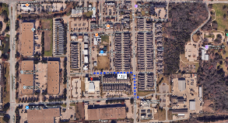


1000-1015: Break
Coppell Arts Center
<<< S. Coppell Rd. >>>
<<< Freeport Pkwy. >>>
Life Safety Park
Construction Zone /
No Parking
Hard 8 BBQ
Twisted Root Burger Co.
George Coffee
The Diner
The Deli
<<< W. Bethel Rd. >>>
1015-1145: Breakout Session 5 @ Life Safety Park
Magic (Stage) – Dusty Simmons, Haltom City Police Department
Train Station
“Howdy Partner” – Neal Skoy
Classroom B
Sound Gone Wrong - Jeff Bates; Plano Fire Department
Safety House
1145-1315: Lunch (Provided by CFD & Life Safety Park) @ Coppell Arts Center
1315-1445: Breakout Session 6 @ Life Safety Park
Putting It All Together – Derek Paradise; Texas LAFS
Classroom B
Sound Gone Wrong - Jeff Bates; Plano Fire Department
Safety House
Song Writing – Hank Morrow; Texas LAFS
Train Station
1445-1500: Break
1500-1530: Texas LAFS Live Show @ Life Safety Park
1530-1630: Raffle Drawing & Closing Remarks

Conference Map
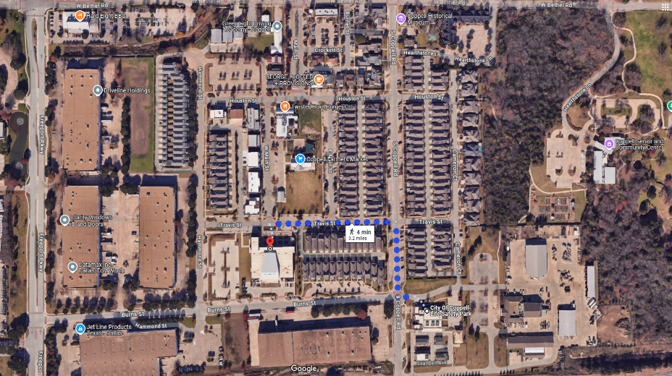
Coppell Arts Center
<<< S. Coppell Rd. >>>
<<< Freeport Pkwy. >>>
Construction Zone /
No Parking
Hard 8 BBQ
Twisted Root Burger Co.
George Coffee
The Diner
The Deli
<<< W. Bethel Rd. >>>
Life Safety Park
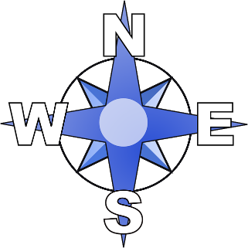
= Parking Area

